Earthquake and tsunami 'Japan's worst crisis since
World War 2'
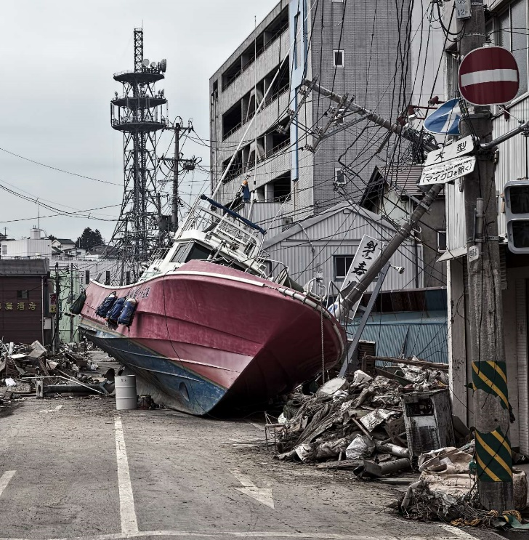
Sun 13 March, 2011

Prime minister Naoto Kan speaks as Japanese struggle to avert nuclear disaster and police say death toll could top 10,000
Japan is facing its biggest crisis since the second world war, the prime minister Naoto Kan has said, as the country battled to avert a nuclear disaster after the devastasting earthquake and tsunami.
Police have warned that the death toll could rise to 10,000 in one prefecture alone and national broadcaster NHK reported that more than 1,100 people were now confirmed dead. Most are thought to have drowned.
Authorities were fighting to keep temperatures down in multiple reactors at two plants in Fukushima prefecture, warning that a partial meltdown was possible in one and that there was a risk of a second hydrogen explosion in another.
Neither would necessarily breach the reactor's containment vessel, and authorities played down the likelihood of a substantial release of radiation. As many as 190 people had already been exposed, a Japanese official told Reuters, with 22 confirmed to have suffered contamination.
"The earthquake, tsunami and the nuclear incident have been the biggest crisis Japan has encountered in the 65 years since the end of world war two," Kan told a news conference.
"We're under scrutiny on whether we, the Japanese people, can overcome this crisis."
Friday's 8.9 magnitude earthquake - the worst in Japan's recorded history and the fifth worst worldwide in the last century - caused a tsunami up to 10 metres high.
As aftershocks continued to shake the north-east region, the Japanese meteorological agency warned that there was a 70% possibility of a magnitude seven or greater tremor in the next three days.
There was some relief for the battered coast as the agency lifted the tsunami warning, although it said aftershocks could cause further waves.
Tokyo has doubled the number of troops in its rescue and relief team to 100,000, but damage to roads and bridges has hampered their efforts.
Survivors in the disaster zone huddled in public shelters for a third night in near freezing temperatures. About 300,000 people have been displaced or evacuated due to the tsunami and radiation fears.
At least 10,000 people were feared killed by the earthquake in Miyagi prefecture alone, its police chief told NHK. The broadcaster said 550 people were confirmed dead there, 335 in Iwate and 285 in Fukushima.
With phone services still down in many areas, survivors made their way to civic centres to check boards with names of others known to have survived and those who had died.
Etsuko Oyama, who was rescued by a neighbour after the wave swept her 400 metres from her home, struggled to hold back tears as she spoke to NHK.
"I grabbed my daughter's hand but I lost my grip when I was swept away by the debris and water," she said.
"I managed to survive but my daughter was washed away ... I hope she is still alive somewhere."
There were welcome moments of celebration as survivors were reunited, but no good news was unalloyed by grief.
Japanese troops rescued a 60-year-old man found 10 miles out to sea on the roof of his home. But Hiromitsu Shinkawa said his wife had been swept away when the tsunami hit as they returned home to gather possessions after the quake.
International relief teams from countries including China, the US and the UK are arriving to help Japanese troops. Almost 70 countries have offered anything from sending nuclear experts and sniffer dog squads to shipping in food and blankets.
Donors included the city of Kandahar in southern Afghanistan. "I know $50,000 is not a lot of money for a country like Japan, but it is a show of appreciation from the Kandahar people," mayor Ghulam Haidar Hamidi told Reuters.
News agency Kyodo reported that more than 20,000 buildings nationwide were either destroyed or badly damaged. Some 2 million households were without power, and 1.4 million without drinking water, Japan's ministry of health, labour and welfare said - although electricity was restored to some parts of Sendai city.
Power generation has fallen sharply due to the closure of nuclear plants and officials have ordered rolling three-hour blackouts across Tokyo and the surrounding area from tomorrow. Demand is substantially higher during the week than at weekends.
"We have to avoid at all costs a sudden power shortage whose scale could have devastating consequences for the economy and people's lives," Kan told a press conference.
NHK reported that the blackouts could last until the end of next month.
The nuclear crisis has prompted many to reassess the use of nuclear power in other parts of the world.

